ROADWATCH
Project Presentation Notes and Validation Checklist
Design of Smart Cities | Tamil Nadu Smart Cities Project | Sidak Singh | VIT Chennai

1. Opening (30-45 seconds)
“Roadwatch is a geospatial dashboard for organizing road-defect records for municipal review. It brings location markers, severity, timestamps, work status, workload indicators, and record-level actions into one interface. The current focus is the operator workflow: inspect a location, find the relevant record, and track its maintenance status.”

2. Problem and objective (45 seconds)
Road defects need to be reviewed by location and urgency. A map alone does not manage follow-up, while a table alone hides spatial patterns. Roadwatch links both views and adds severity summaries and maintenance-state actions. The intended use is to help municipal teams prioritize review and coordinate maintenance.

3. Architecture and workflow (60 seconds)
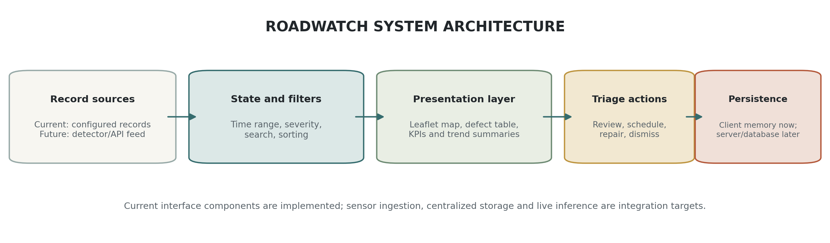
Explain the sequence: records -> shared filters -> map/table and summaries -> detail drawer -> status action. Be explicit that the current data records are configured in the page and status updates are held in browser memory. A real deployment needs an authenticated API, database, and verified upstream data.

4. Live interface walkthrough (90 seconds)
- Open the overview and point out the KPI cards and critical-attention banner.
- Use the 24-hour, 7-day and 30-day controls and explain how the current time window scopes the records.
- Search by a road name and then by a defect identifier.
- Use severity/status chips and sort by confidence or severity.
- Click a map marker and then a table row; point out that both open the same record drawer.
- For a record, show scheduling, repair, dismissal or reopening actions. Explain that the current browser version does not persist updates to a server.
- Point to the map attribution and explain that road positions must come from validated field coordinates before operational dispatch.

5. Implemented vs. required next steps
Implemented in current source | Required before operational rollout
Leaflet basemap integration and severity-coded markers | Verified GPS feed and coordinate-quality checks
Linked map, table, search, filters and sorting | Backend API, persistent database and audit history
KPI, severity mix, trend display and record drawer | Authenticated roles and permission checks
Client-side maintenance status actions | Crew dispatch integration and notifications
Configured defect record fields | Validated upstream detector/reporting pipeline and recorded accuracy tests

6. Questions likely to be asked
What is the main contribution? A linked operator interface that unifies geospatial inspection and maintenance-status triage.
Does Roadwatch detect potholes using AI? The current source does not embed a trained vision model. It presents structured road-defect records; a detector can be integrated through a defined API later.
How are locations obtained? The interface uses configured latitude/longitude values. A field system should supply GPS-tagged records and validate coordinates before dispatch.
Are the status changes saved permanently? They currently update client-side state. Server persistence and audit history are next engineering requirements.
How was accuracy measured? No computer-vision accuracy or geolocation-error study has been conducted for this implementation. Avoid claiming accuracy metrics.
How does this relate to Smart Cities? It supports a digitally organized municipal road-maintenance workflow; public value must be evaluated in a future pilot.
Is the interface patentable? No legal novelty claim is made. Public prior art covers road-damage sensing, geolocation, mapping and maintenance reporting; an IP professional must review the detailed claims.

7. Evidence to collect before submission
- Capture dated screenshots of the map, filtered table, detail drawer, KPI views and status transitions.
- Record the browser and screen size used for each test and maintain a pass/fail log.
- Add an API/database test only after those components exist; do not describe planned items as implemented.
- For a future detection evaluation, use a labeled, location-aware holdout set and report precision, recall, F1, latency and coordinate error.
- Insert all team members, institution email, faculty guide, and approved project naming before submission.

Suggested references
[1] H. Maeda, Y. Sekimoto, T. Seto, T. Kashiyama, and H. Omata, “Road damage detection and classification using deep neural networks with smartphone images,” Computer-Aided Civil and Infrastructure Engineering, vol. 33, no. 12, pp. 1127–1141, 2018, doi: 10.1111/mice.12387.
[2] D. Arya et al., “RDD2022: A multi-national image dataset for automatic road damage detection,” Geoscience Data Journal, vol. 11, no. 4, pp. 846–862, 2024, doi: 10.1002/gdj3.260.
[3] S. H. Abdelwahed et al., “Advancements in real-time road damage detection: a comprehensive survey of methodologies and datasets,” Journal of Real-Time Image Processing, vol. 22, Art. no. 137, 2025, doi: 10.1007/s11554-025-01683-1.
[4] Leaflet contributors, “Leaflet Quick Start Guide,” Leaflet documentation. [Online]. Available: https://leafletjs.com/examples/quick-start/ (accessed Oct. 11, 2026).
[5] OpenStreetMap contributors, “Copyright and License.” [Online]. Available: https://www.openstreetmap.org/copyright (accessed Oct. 11, 2026).
[6] United Nations, “Goal 11: Make cities and human settlements inclusive, safe, resilient and sustainable.” [Online]. Available: https://sdgs.un.org/goals/goal11 (accessed Oct. 11, 2026).
[7] Ministry of Housing and Urban Affairs, Government of India, “Smart Cities Mission Achievements,” Press Information Bureau, Dec. 18, 2024. [Online]. Available: https://www.pib.gov.in/Pressreleaseshare.aspx?PRID=2085711.

